

# Accessibility Guide for The Writers' Museum

[museumsandgalleries@edinburgh.gov.uk](mailto:museumsandgalleries@edinburgh.gov.uk), [+44 (0) 131 529 4901,](tel:+44%20(0)%20131%20529%204901) <https://www.edinburghmuseums.org.uk/venue/writers-museum>

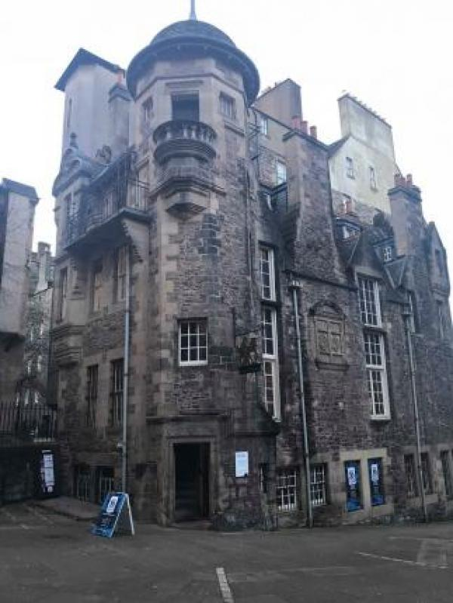

### Welcome

The Writers’ Museum celebrates the lives of three giants of Scottish Literature – Robert Burns, Sir Walter Scott and Robert Louis Stevenson.

Home to portraits, rare books and personal objects including Burns’ writing desk, the rocking horse Scott used as a child and Stevenson’s riding boots and the ring given to him by a Samoan chief, engraved with the name ‘Tusitala’, meaning ‘teller of tales’. There is also a plaster cast of Robert Burns' skull, one of only three ever made.

Unfortunately, due to the historic nature of the building, the exhibitions are accessible by stairs only.

## At a Glance

### Level Access

* The main entrance has 1 step and a handrail. There is no lift and no ramp.

### Access with steps

* There are steps from the main entrance to:
  + Lower ground floor
  + First floor
  + 2nd floor
  + Reception/Shop desk
  + Second floor toilets
  + First floor shop

### Visual

* Some parts of the venue have low lighting.
* We have display information in large print and other.

## Getting here

Lawnmarket  
Lady Stair's Close  
Edinburgh  
EH1 2PA

#### Travel by public transport

* You can get to The Writers' Museum by bus, train and tram.
* The bus stop is called "The Mound" with bus routes 23 and 27. More information can be found here: https://www.lothianbuses.com/timetables/ The bus stop is 0.20 miles / 62.8 km from The Writers'.0; Museum.
* The nearest train station is Waverley Railway Station. The train station is 0.3 miles / 0.5 km from The Writers' Museum.
* The nearest tram station is Princes Street. The tram station is 0.3 miles / 0.5 km from The Writers' Museum.

#### Travel by taxi

* You can get a taxi with City Cabs by calling 0131 228 1211. The taxi company has a wheelchair accessible vehicle.

#### Parking

* The museum is situated off the main road, on a courtyard. The road is a busy tourist area. There is no designated drop-off area with a dropped kerb. The Writer's Museum is located in Lady Stair's Close and the nearest bus stop is only accessible via stairs. For more accessible way from the mound bus stop to the museum, you can travel on foot via Bank Street which brings you to the Lawnmarket.

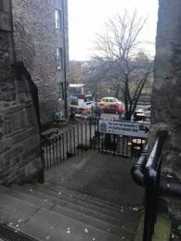  
Lady Stair's Close

## Arrival

#### Path to main entrance

* From the street to the main entrance, there is 1 step. There is no ramp and no lift.

#### Main entrance

* The door is 900mm wide.
* The main entrance has 1 steps.
* This entrance has a handrail.
* The main door is side hung and manual.
* Unfortunately, due to the age of the building, the Writers museum is not accessible for wheelchairs users and visitors with limited mobility may struggle because the museum is located on several floors with no lift.

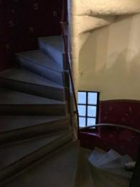  
Example of spiral stairs in the museum from the basement to upper floors

## Getting around inside

#### Visual Impairment - General Information

* Some parts of the venue have low lighting.

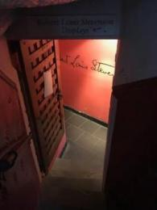  
The stairs to the basement exhibit about Robert Louis Stevenson are low lit

#### Ticket/ information desk

#### Reception/Shop desk

* From the main entrance to this desk, there are 8 steps. There is no lift and no ramp.
* Regrettably, the museum (including the shop, toilets and information desk) is inaccessible for wheelchair users. The stairs are uneven and hazardous, especially later in the day when it is darker inside.

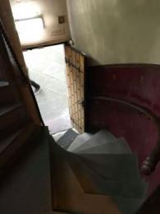  
View from the first floor to the entrance

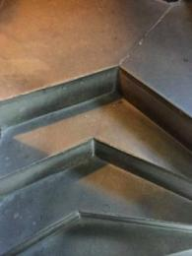  
Close-up of the stairs: as you see, they are unevenly shaped

#### Things to See and Do

* We have display information in: large print .
* Information is available in different languages including: French, Italian, German, Spanish and Japanese. Large print version of all museum text available on request.

#### Lower ground floor

* From the main entrance to this area, there are 6 steps. There is no lift and no ramp.
* There are seats.
* A volunteer guide in this area devoted to Robert Louis Stevenson's life and works would be very happy to tell you more about the exhibits.

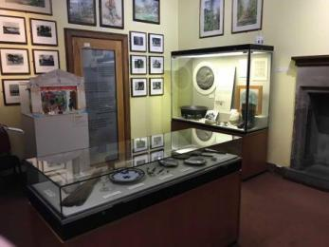  
Lower ground floor: Robert Louis Stevenson display

#### First floor

* From the main entrance to this area, there are 8 steps. There is no lift and no ramp.
* There are seats.
* The temporary space exhibit, the Robert Burns rooms and the shop/ information desk are on the first floor. The Robert Burns rooms are to the side of the main space, located up 3 steps.

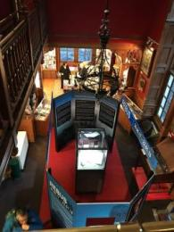  
The temporary exhibit space photographed from above

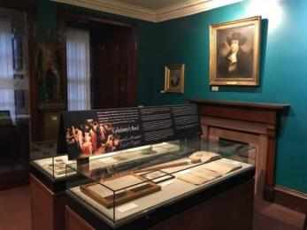  
Robert Burns room where you can hear traditional Scottish music which adds to its atmosphere

#### 2nd floor

* From the main entrance to this area, there are 27 steps. There is no lift and no ramp.
* There are seats.
* The second floor is dedicated to Sir Walter Scott and other Scottish writers, old and new. There is a very narrow staircase up to this floor and a balcony with a small dedicated reading space with sofas. The steps are varying heights and the ceiling is low. A feature of some old houses, it was intended as a type of burglar because people would stumble and be caught.

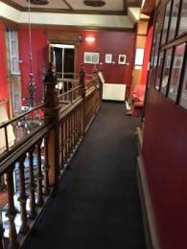  
The balcony

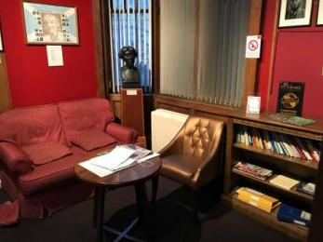  
The reading space and the visitor's book where you can tell us all about your visit

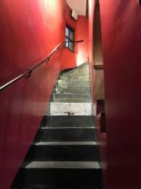  
Narrow stairs up to the second floor (680 mm wide).

#### Public toilet

#### Second floor toilets

* From the main entrance to the public toilet, there are 27 steps. There is no lift and no ramp.

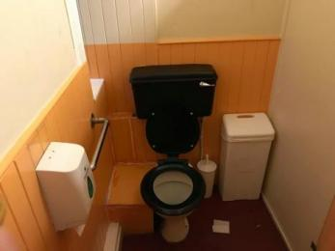  
Public toilet.

#### Shop

#### First floor shop

* From the main entrance to the shop, there are 8 steps. There is no lift and no ramp.

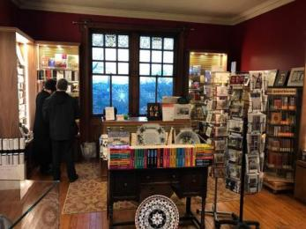  
Shop/ information desk

## Customer care support

#### Accessibility equipment

* The nearest toilet area for assistance dogs is just outside the museum, in Lady's Stairs Close. Also, we are near to Princes Street Gardens.

#### Emergency evacuation procedures

* There is only one way in and out for the museum. The emergency exit is signed and there is a visitors assistance to help you in that case. Assembly point is located in the courtyard.

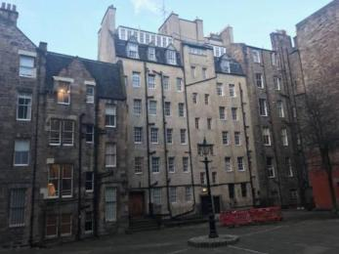  
The courtyard

Guide last updated: 25 July 2023