**Volunteer Role Description**

**Museum of Edinburgh Courtyard Volunteer**

|  |  |
| --- | --- |
| **Supervisor** | Ria Sloan  Outreach and Access Manager  0131 529 4143  [ria.sloan@edinburgh.gov.uk](mailto:ria.sloan@edinburgh.gov.uk) |
| **Information** | The Museum of Edinburgh courtyard is an oasis of calm next to the Royal Mile. It contains stone fragments from some of Edinburgh’s oldest buildings that are no longer standing, as well as a variety of plants, flowers and herbs.  The bottom of the courtyard is focused on climate friendly gardening, with a water butt, compost bin, bird table, nature mural and seating made from reclaimed wood. |
| **Role Purpose** | To help maintain and develop the courtyard garden as a pleasant and welcoming public space. |
| **Responsibilities** | * Welcoming and interacting with visitors to the courtyard * Watering and maintaining the plants in the space * Keeping the courtyard clean and free of weeds * Planting new flowers and herbs as required * Any other required responsibilities related to the role, as agreed between the volunteer and supervisor |
| **Knowledge, Skills & Experience** | * Interest in gardening * Interest in Edinburgh’s history * Good communication skills * Happy to work largely unsupervised * Knowledge of/interest in composting useful but not essential |
| **Commitment** | Half a day per week during Spring/Summer/Autumn (weather permitting). The courtyard is open between 01 April – 30 September. |
| **Support & Training** | Volunteers will be given an induction to the courtyard.  Support and supervision will be provided, with regular meetings to discuss the role. |
| **Expenses** | Pre-paid bus tickets for journeys within Edinburgh can be provided. |
| **Expectations** | * Be courteous to members of the public, volunteers and staff * Commit to agreed dates and times * Arrive at sessions and meetings on time * Give reasonable notice if unable to attend * Abide by the City of Edinburgh Council’s policies and codes of conduct |
| **Access information** | Due to the historic nature of the building there is no lift access within the museum. The courtyard is accessible through the museum which involves coming up and then down two separate flights of stairs. Toilets are located at the museum reception and on the first floor of the museum. |
| **Location** | Museum of Edinburgh, 142 Canongate, Royal Mile, Edinburgh, EH8 8DD |

*Updated: 27 March 2025*

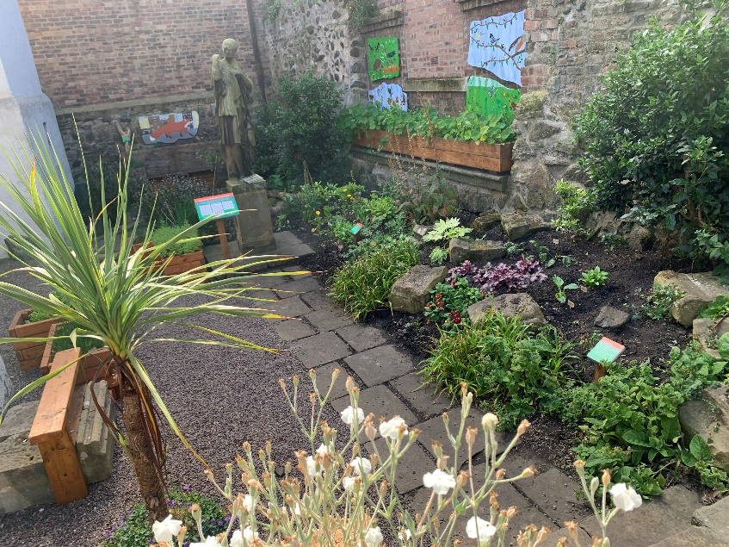

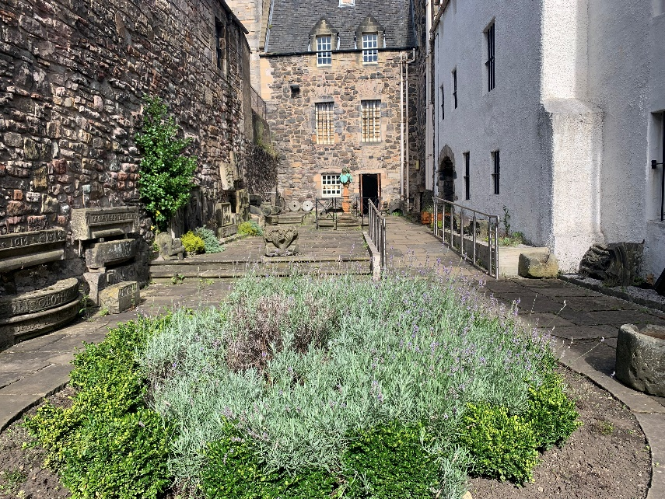

*The Museum of Edinburgh Courtyard*