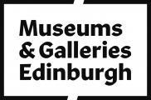

# Accessibility Guide for Queensferry Museum

[museumsandgalleries@edinburgh.gov.uk](mailto:museumsandgalleries@edinburgh.gov.uk), [+44 (0) 131 331 5545,](tel:+44%20(0)%20131%20331%205545) <https://www.edinburghmuseums.org.uk/venue/queensferry-museum>

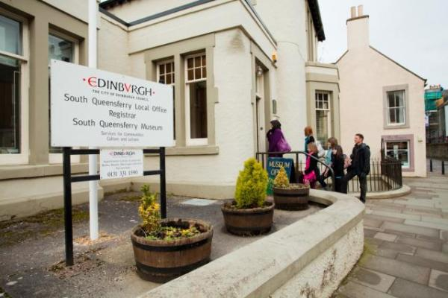

### Welcome

Queensferry museum showcases the past and traditions of historic Queensferry and neighbouring Dalmeny. Whether your interest is social history, folk traditions or civic engineering, there is something here for everyone to enjoy.

As well as permanent displays, the museum hosts a room dedicated to temporary exhibitions, curated by community groups.

Unfortunately, the exhibitions are accessible by stairs only.

## At a Glance

### Level Access

* The main entrance has 3 steps and a handrail. There is no lift and no ramp.

### Access with steps

* There are steps from the main entrance to:
  + First floor
  + Information desk

## Getting here

53 High Street  
South Queensferry  
Queensferry  
EH30 9HP

#### Travel by public transport

* You can get to Queensferry Museum by bus.
* The bus stop on Stonycroft Road is 3 minutes away on foot. The bus stop is 0.1 miles / 0.2 km from Queensferry Museum.

#### Travel by taxi

* You can get a taxi with City Cabs by calling 0131 228 1211. The taxi company has a wheelchair accessible vehicle.

#### Parking

* We have a car park. There are accessible parking spaces. The parking is less than 50 metres from the main entrance. Parking is free.
* There is a drop-off point at the main entrance. The drop-off point has a dropped kerb.
* From the parking to the main entrance, there are 3 steps. There is no ramp and no lift.
* The car parking is adjacent to the museum, less than 1 minute away.

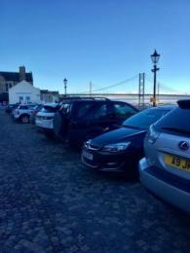

## Arrival

#### Main entrance

* The main entrance has 3 steps.
* This entrance has a handrail.
* The main door is side hung and manual.

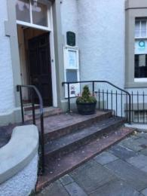  
Main entrance

## Getting around inside

#### Ticket/ information desk

#### Information desk

* From the main entrance to this desk, there are 22 steps. There is no lift and no ramp.
* The desk is on your way to Gallery 1 and 2, on your right when you come from the stairs.

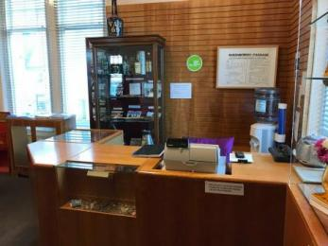

#### First floor

* From the main entrance to this area, there are 22 steps. There is no lift and no ramp.
* There are seats.
* All the museum is located on the first floor, consisting of 4 small gallery spaces.

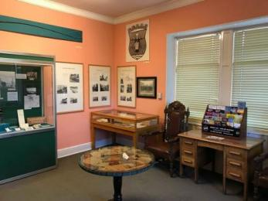  
Example of a gallery

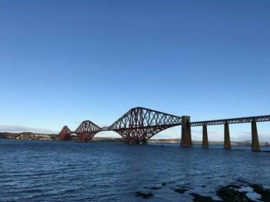  
View from spectator area (Gallery 3)

## Customer care support

#### Accessibility equipment

* The nearest toilet facilities for assistance dogs is located on the street. There is a car park just outside the museum and there is no garden. There is King George V park located at Farquhar Terrace about 15 minutes walk away.

Guide last updated: 4 July 2023