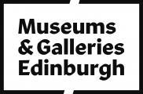

# Accessibility Guide for Nelson Monument

[museumsandgalleries@edinburgh.gov.uk](mailto:museumsandgalleries@edinburgh.gov.uk), [+44 (0) 131 556 2716,](tel:+44%20(0)%20131%20556%202716) <https://www.edinburghmuseums.org.uk/venue/nelson-monument>

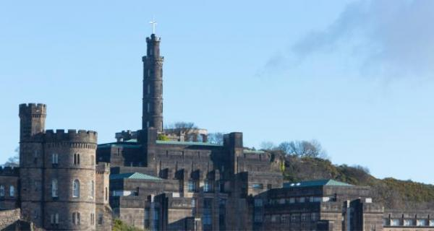

### Welcome

This monument commemorates Admiral Horatio Lord Nelson and became a naval signaling station soon after it was completed.  A visit to the Nelson Monument offers a great opportunity to explore one of Edinburg's most famous landmarks and stunning views of the city.

Unfortunately due to the historic nature of the building, the monument is accessible by steps only.

## At a Glance

### Level Access

* The main entrance has 2 steps. There is no lift and no ramp.

### Access with steps

* There are steps from the main entrance to:
  + Calton Hill

### Visual

* Some parts of the venue have low lighting.
* We have display information in braille, large print and other.

### General

* We have a complimentary ticket policy for personal assistants.

## Getting here

32 Calton Hill  
Edinburgh  
EH7 5AA

#### Travel by public transport

* You can get to Nelson Monument by bus, train and tram.
* Many city bus routes pass by or close to the East end of Princes Street. Waterloo place is the nearest stop for buses towards Edinburgh West. The bus stop is 0.2 miles / 0.3 km from Nelson Monument.
* The nearest train station is Waverley. The train station is 0.5 miles / 0.8 km from Nelson Monument.
* The nearest tram station is Either St Andrews Square or York Place. The tram station is 0.5 miles / 0.8 km from Nelson Monument.
* Both tram stops are about the same distance from the Nelson Monument

#### Travel by taxi

* You can get a taxi with City Cabs by calling 0131 228 1211. The taxi company has a wheelchair accessible vehicle.

#### Parking

* At the bottom of Calton Hill, there are metered parking areas. The monument is only accessible via a steep walk up Calton Hill.

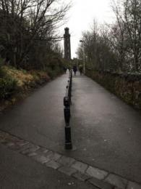  
View from the bottom of Calton Hill

## Arrival

#### Path to main entrance

* From the street to the main entrance, there are 84 steps. There is no ramp and no lift.
* The path is sloped.

#### Main entrance

* The main entrance has 2 steps.
* The main door is side hung and manual.

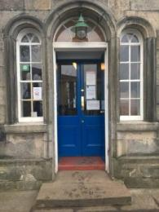  
Main entrance

## Getting around inside

#### Visual Impairment - General Information

* Some parts of the venue have low lighting.

#### Ticket/ information desk

#### Ticket/ information desk

* When you arrive, a dedicated visitor assistant will be at the barrier selling entrance tickets to the monument museum and tower. Tickets cost 5 pounds. If you need further information, the Monument staff will be happy to help.

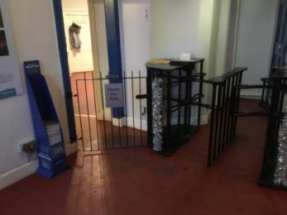  
Welcome area and ticket barrier

#### Things to See and Do

* We have a complimentary ticket policy for personal assistants.
* We have display information in: braille, large print .
* Visit guides are translated in German, French and Spanish

#### Ground floor museum

* Some display information is low, for wheelchair users. There are seats.
* Learn about the history of the building and Edinburgh's sea faring past in this exhibition space.

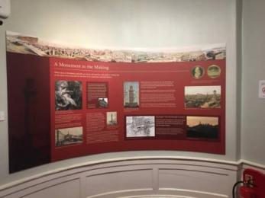  
Display panel in exhibition room

## Getting around outside

#### Calton Hill

* From the main entrance to the area, there are 55 steps.
* On the hill, you can enjoy the astonishing view of the city of Edinburgh and some of the other historic monuments, including the Dugald Stewart Monument and the Scottish National Monument.

## Customer care support

#### Accessibility equipment

* Calton Hill is a great area for dog walking
* We have other services for people with accessibility requirements.
* The Nelson and Scott Monument information leaflet can be ordered on tape in Braille, large print or in other electronic formats if required. Please contact the Interpretation and Translation Service (ITS) on 01312428181 and quote reference number: 13-0782.

Guide last updated: 4 July 2023