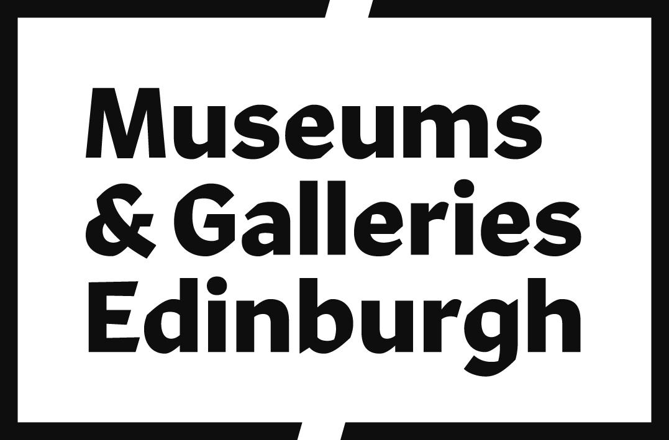

# Accessibility Guide for Museum of Childhood

[museumsandgalleries@edinburgh.gov.uk](mailto:museumsandgalleries@edinburgh.gov.uk), [0131 529 4142 ,](tel:0131%20529%204142%20) <https://www.edinburghmuseums.org.uk/venue/museum-childhood>

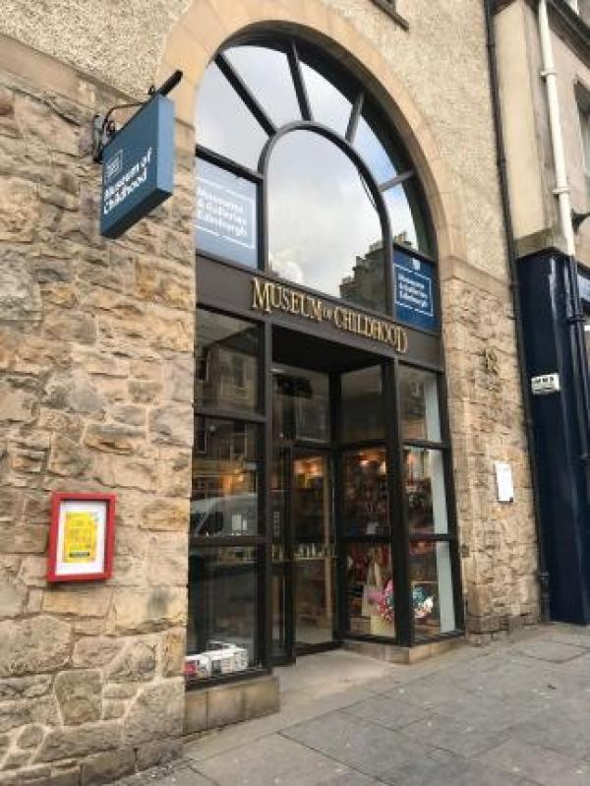

### Welcome

The first museum in the world dedicated to the history of childhood, it displays toys and games from across the generations. The Museum also explores other aspects of growing up, from schooldays and clubs to clothing, health and holidays. The brand new Gallery One features 60 rarely-seen objects relating to childhood life, learning and play following a five-month refurbishment of the ground floor.

## At a Glance

### Level Access

* The main entrance has level access with a ramp. The ramp is permanent.
* There is level access from the main entrance to:
  + Gallery 1: Changing Childhood
  + Gallery 2: Toys
  + Gallery 3: Dolls and Soft Toys
  + Front and shop desk
  + Accessible Toilet and baby changing facilities
  + Gift shop

### Access with steps

* There are steps from the main entrance to:
  + Gallery 4: Games and Hobbies
  + Gallery 5: Children's Clothes

### Visual

* Some parts of the venue have low lighting.
* We have display information in audio and large print.

### General

* There is at least 1 public toilet for disabled visitors.

## Getting here

42 High Street  
Edinburgh  
EH1 1TG

#### Travel by public transport

* You can get to Museum of Childhood by bus, train and tram.
* Opposite the museum entrance on the other side of the road. The stop serves Service 35 between the Heriot-Watt University Campus and Ocean Terminal and the City Sightseeing and Edinburgh Tour buses. Here is the online timetable: https://www.lothianbuses.com/timetable/?service_name=35 The bus stop is 0.1 miles / 0.2 km from Museum of Childhood.
* The nearest train station is Waverley Railway Station. The train station is 0.3 miles / 0.5 km from Museum of Childhood.
* The nearest tram station is St Andrews Square . The tram station is 0.5 miles / 0.8 km from Museum of Childhood.
* If not using public transport and travelling via foot to Princes Street, we recommend travelling via Jeffrey Street, then Market Street opposed to via the Royal Mile. Jeffrey Street is downhill, sloped and wheelchair accessible as there are no stairs.

#### Travel by taxi

* You can get a taxi with City Cabs by calling 0131 228 1211. The taxi company has a wheelchair accessible vehicle.
* If you require a taxi, please contact the front desk and they will be happy to help you.

#### Parking

* There is a drop-off point at the main entrance. The drop-off point has a dropped kerb.
* The Museum is located on the Royal Mile, which gets very busy during the day. There is no on-street parking and restricted drop-off areas. However, there is a bus stop with a dropped kerb outside the museum. A quick drop-off is then possible, but it is difficult to wait for people for a long period of time.

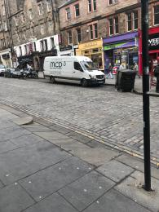  
Dropped kerb in front of museum entrance.

## Arrival

#### Path to main entrance

* From the street to the main entrance, there is level access.
* There is a permanent ramp.
* The path is 1600mm wide, or more.
* The path is sloped.

#### Main entrance

* The main entrance has level access.
* There is a permanent ramp.
* The door is 1600mm wide.
* The main door is side hung and manual.
* Museum staff based in the shop will be very happy to assist with opening and closing doors.

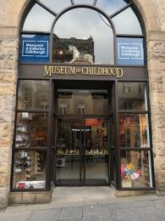  
To the bottom of the picture, there is a sloped path before the entrance.

## Getting around inside

#### Visual Impairment - General Information

* Some parts of the venue have low lighting.

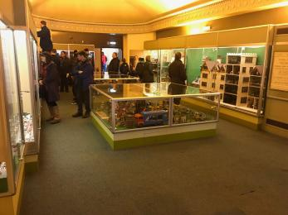  
View of Gallery 2. Compared to the newly refurbished Gallery 1, the older gallery spaces are more low lit.

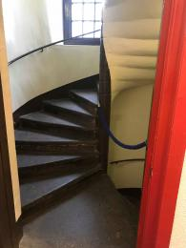  
Back spiral staircase to galleries 3, 4, and 5.

#### Lift

* We have 1 lift.
* You can get a lift to some floors.

#### Main lift from ground floor to second floor

* The lift door is 800mm wide.
* 3 out of the 5 galleries are accessible via the lift; including the newly refurbished Gallery 1 Changing Childhood, Gallery 2 Toys and Gallery 3 Dolls and Soft Toys. Unfortunately, Gallery 4 Games and Hobbies and Gallery 5 Children's Clothes are not wheelchair accessible.

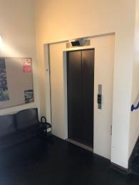  
Lift on Level 1

#### Ticket/ information desk

#### Front and shop desk

* From the main entrance to the desk, there is level access. The route is 1600mm wide, or more.
* The door is 1600mm wide, or more.
* The desk has a low section.
* The lower part of the desk is 670mm high.

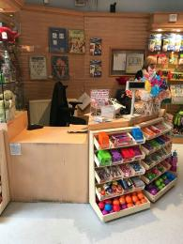  
Entrance desk and shop till

#### Things to See and Do

* We have display information in: audio and large print.

#### Gallery 1: Changing Childhood

* From the main entrance to this area, there is level access. The door is 1600mm wide.
* Some display information is low, for wheelchair users. There are seats.
* Gallery 1 is newly refurbished and an open plan space.

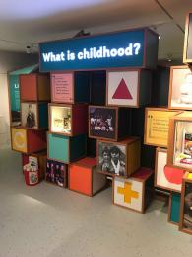  
Gallery 1 introductory display.

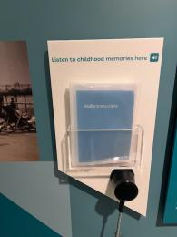  
Audio and large print transcripts.

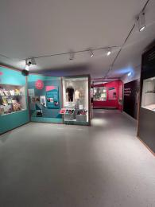  
Gallery 1 display.

#### Gallery 2: Toys

* From the main entrance to this area, there is level access. There is a lift.
* From the lift to this area, the route is 1260mm wide, or more. Some display information is low, for wheelchair users. There are seats.

  
Gallery 2 space

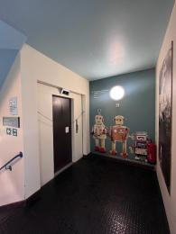  
Lift from ground floor.

#### Gallery 3: Dolls and Soft Toys

* From the main entrance to this area, there is level access. There is a lift.
* Some display information is low, for wheelchair users. There are seats.

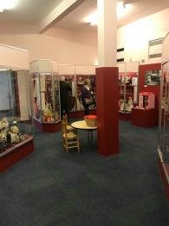  
Gallery 3 space

#### Gallery 4: Games and Hobbies

* From the main entrance to this area, there are 26 steps. There is no lift and no ramp.
* Some display information is low, for wheelchair users. There are seats.

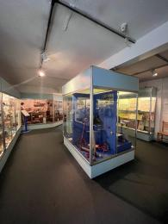  
Gallery 4 space.

#### Gallery 5: Children's Clothes

* From the main entrance to this area, there are 44 steps. There is no lift and no ramp.
* Some display information is low, for wheelchair users. There are seats.

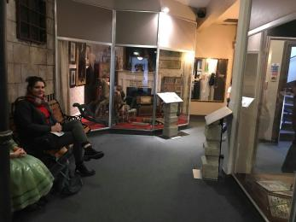  
Gallery 5 space.

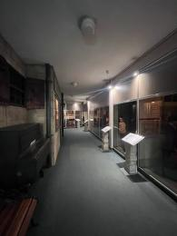  
Gallery 5 space.

#### Public toilet

#### Accessible Toilet and baby changing facilities

* There is a public toilet for disabled visitors.
* From the main entrance to the public toilet, there is level access. There is a lift.
* The toilet door is 890mm wide.
* There is 2400mm in front of the toilet. The toilet seat is 460mm high. The toilets have handrails.

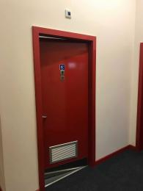  
Accessible Toilet entrance at the back of Gallery 3

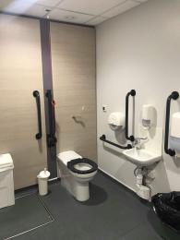  
Accessible toilet

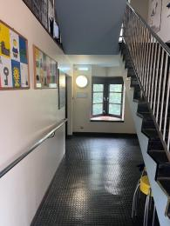  
Hallway to the accessible toilet.

#### Shop

#### Gift shop

* From the main entrance to the shop, there is level access. The door is 1600mm wide.
* The route through the shop is 800mm wide, or more.
* The shop is open plan and located directly inside the main entrance. There is an information desk and till in the shop where staff will be happy to assist.

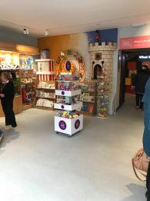  
Open plan gift shop

## Customer care support

#### Accessibility equipment

* There is not toilet area for assistance dogs in the museum. The nearest place is a public park (Holyrood Park) about 0, 3 miles from the museum.

Guide last updated: 4 July 2023