

# Accessibility Guide for Makars' Court

[museumsandgalleries@edinburgh.gov.uk](mailto:museumsandgalleries@edinburgh.gov.uk), <https://www.edinburghmuseums.org.uk/venue/makars-court>

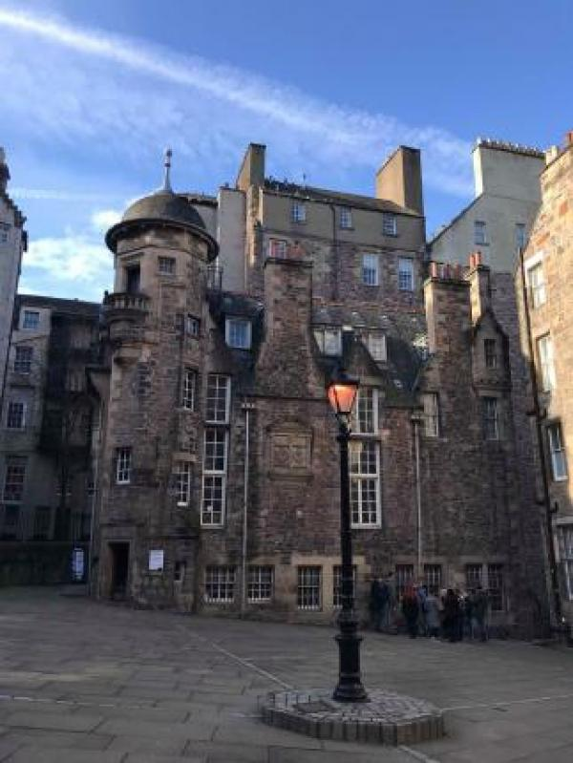

### Welcome

Makars’ Court is an evolving national literary monument where you can see some of the famous words of great Scottish writers inscribed in the flagstones. The Scots word Makar means ‘one who fashions, constructs, produces, prepares, etc.’ (Dictionary of the Scots Language), and in a literary context it is the role of the poet or author as a skilled and versatile worker in the craft of writing.

Look out for quotes ranging from the 14th century John Barbour to Dame Muriel Spark who died in 2006. New flagstones are added on a regular basis.

## At a Glance

### Level Access

* The main entrance has level access with a ramp. The ramp is permanent.

## Getting here

Lawnmarket  
Lady Stair's Close  
Edinburgh  
EH1 2PA

#### Travel by public transport

* You can get to Makars' Court by bus, train and tram.
* The bus stop is called "Mound Place" with bus routes 23, 27, 41, 42, 67. More information can be found here:https://lothianbuses.co.uk/timetables-and-maps. The bus stop is 0.10 miles / 62.8 km from Makars'.0; Court.
* The nearest train station is Waverley Station. The train station is 0.3 miles / 0.5 km from Makars' Court.
* The nearest tram station is Princes Street. The tram station is 0.4 miles / 0.6 km from Makars' Court.

#### Parking

* Makars' Court is situated off the Royal Mile which is a busy tourist area. There is no designated drop-off area with a dropped kerb.

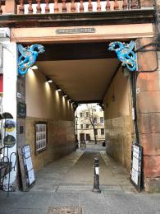  
Pedestrian passage from the Royal Mile to Makars' Court

## Arrival

#### Path to main entrance

* From the street to the main entrance, there is level access.
* There is a permanent ramp.
* The path is sloped.

#### Main entrance

* The main entrance has level access.
* There is a permanent ramp.
* Makars' Court is a courtyard. You can access it from the Royal Mile via a path on a slope but without any steps. You can also access it from North Bank Street via stairs (26 steps).

  
Accessible path from the Royal Mile to Makars' Court

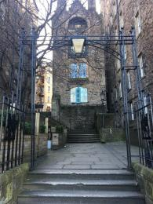  
Access from North Bank Street via stairs

## Getting around inside

## Customer care support

#### Accessibility equipment

* Because Makar's Court is situated in a courtyard (Lady's Stairs Close), it could be used as a toilet area for assistance dogs. We are also near to Princes Street Gardens.

Guide last updated: 25 July 2023